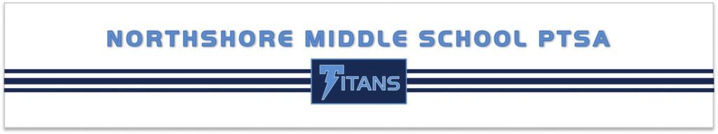
Support your child’s education – Become a member of the PTSA!
The Northshore Middle School PTSA supports:
- Staff and school grants  - Parent Education  - Student Programs  - Staff Appreciation  - Access to books during school shut down | - Emergency Prep  - Volunteer assistance for school  - Child Advocacy at state and national levels  - Classroom & Virtual Classroom Supplies  - Counselor & School Support

PTSA Membership Information
Member: Email:
Member: Email:
Student Name(s) and Grade(s):

Donation Type | Amount
Membership
$25 – 2 people $12 - Staff
$15 – 1 person $0 – Want to join but need assistance
Pass the Hat Donation
Suggested donation $100 per family to fund programs that support NMS students & staff. Pass the Hat is a direct giving campaign. No selling involved! 100% of your donation helps the PTSA fund student and school programs. 100% of your donation is tax deductible.
Emergency Prep Donation
Suggested donation $10 per student. Did you know…. the supplies used in an emergency by the students and staff of Northshore Middle School are funded by the NMS PTSA! Parents thank you for your donations to our PTSA!
Membership Scholarship Donation
Help someone become a member today! Any amount is helpful.
This is a great way to sponsor a staff member.
Total - Write a single check to NMS PTSA
Mail your membership form and check to:
NMS PTSA 16904 Juanita Drive NE #130, Kenmore, WA 98028-4828
You can also join and donate online! Visit our website at http://nms-ptsa.org/.
Northshore Middle School PTSA is a 501(c) 3; membership and all donations are tax deductible.
Your canceled check is your receipt. Questions: Email membership@nms-ptsa.org.

General information about PTSA
PTSA membership is about forming a partnership between parents, schools and communities for the benefit of all children.

There is NO obligation! Volunteering to work with NMS PTSA requires you to be a member; however, being a member does not require you to volunteer or attend meetings.

Your annual PTSA membership also strengthens the PTSA’s ability to drive state legislative issues that have an impact on our children and their education such as smaller class sizes and increased state funding. The membership fee goes towards supporting PTSA advocacy infrastructure at the council, regional, and state PTSA levels.

Membership Benefits
- You have a voice and a vote at all meetings
- Shows the community you care about kids
- Exclusive member discounts from Washington State and National PTA such as Office Depot, Key Arena/McCaw Hall, car rentals, and Great Wolf Lodge

For more information
Please visit our website and subscribe to our newsletter at http://nms-ptsa.org.
Like us on Facebook (Northshore Middle School PTSA).

Membership is about supporting students and staff.
The NMS PTSA is here to advocate for ALL students and to help make NMS a better place. http://nms-ptsa.org
Join us at a Zoom PTSA Meeting. Learn more and have an input as to what programs we will support this year.

Wednesday October 7th, 2020
Wednesday November 4th, 2020
Wednesday January 13th, 2021
Wednesday March 3rd, 2021
Wednesday April 7th, 2021
Wednesday May 12th, 2021

*all meetings will be from 7:00pm – 8:30pm PST

*Zoom information will be sent out in our newsletter and available on our website the week prior to the meeting

